12/9/21

8:28PM – 8:40PM

Trying to add my own html index: CRUD

I made a simple .cshtml file for CRUD in the views folder to create the system separately away from the initialized .cshtml files.

I went into Line 49 as a way to open the website page directly when the program runs. 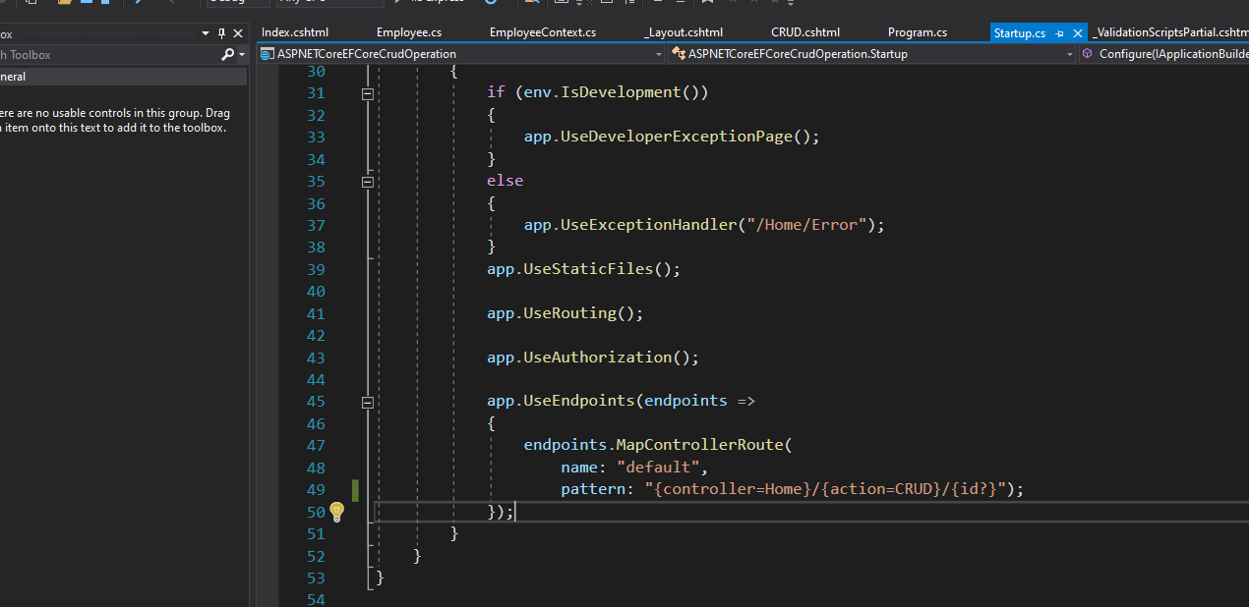It isn’t there yet because it lacks backend to manipulate its direction and it’s called controller. This page ( <https://docs.microsoft.com/en-us/aspnet/core/tutorials/first-mvc-app/adding-view?view=aspnetcore-3.1&tabs=visual-studio#:~:text=Currently%20the%20Index,Index()%0A%7B%0A%20%20%20%20return%20View()%3B%0A%7D> ) helped me. I know that it’s too different to this project but It’s awesome that using documents can help me by using my guesses other than tutorial videos.

I need to go to a controller that is initialized by the template and I guess that it’s HomeController.cs I added my own code there to recognize its selection to CRUD with action.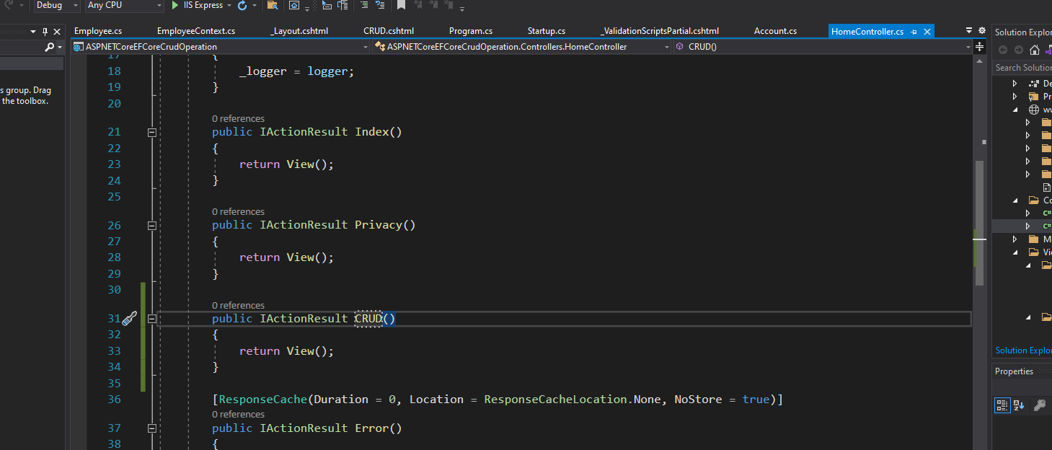I need to make sure the method’s name is same as the .cshtml name file is otherwise an error tells me it couldn’t find it.  
 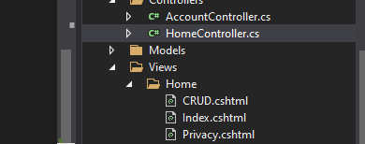  
controllers select which model as it interacts with incoming http request from the website layout. But I still hadn’t mess around with Models yet.

9:18PM

* I noticed that I can’t add <body> in the CRUD.cshtml because the ng-app=”ToDoList” doesn’t work. I must place the attribute in _Layout.cshtml since it is the main system of the html index to what I presumably thought.

10:42PM

* I’m adding a bootstrap from Nuget package. I’m trying to get the awesome UI I saw on this video (<https://www.youtube.com/watch?v=_qIYBgWTlTo&ab_channel=CodAffection> ) in order to look professional.